1. **Access the following URL :** [**https://github.com/yaniv120892/Form-Builder-App**](https://github.com/yaniv120892/Form-Builder-App)
2. **Press “clone or download” and then press “Download ZIP”.**
3. **Extract the zip file content to “Downloads”.**
4. **Open Visual Studio 2015**
5. **Press “Open Project”**

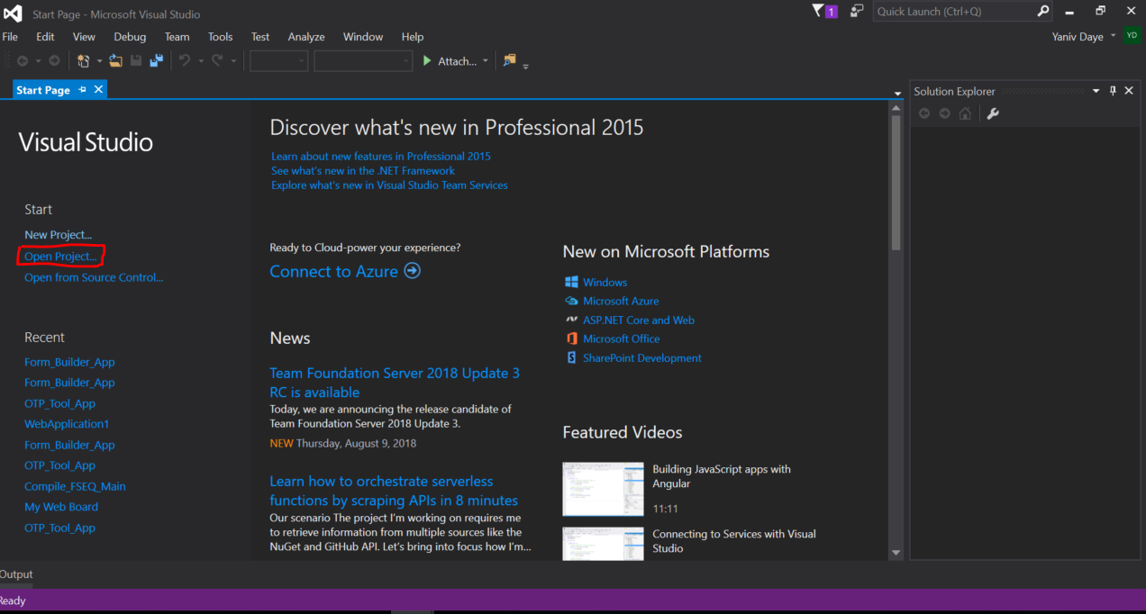

1. **Navigate to “Downloads” folder and click on “Form-Builder-App-master”**

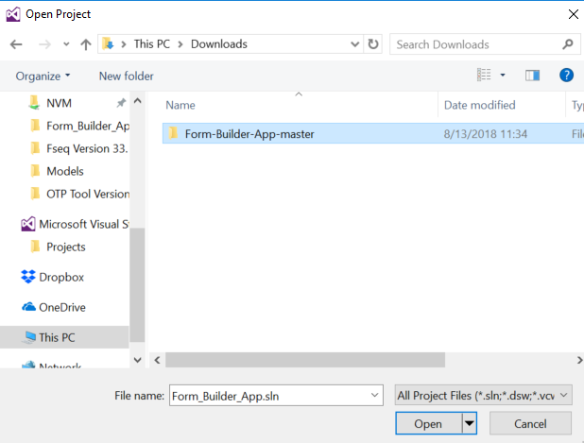

1. **Choose Form_Builder_App.sln**

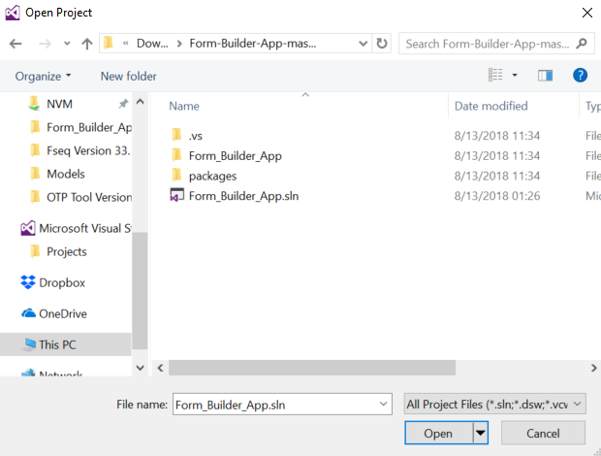

1. **Press on “Google Chrome” as can be seen in the following picture**

